Signing Up to Volunteer

- Go to www.mgseadragons.com and sign into your account.
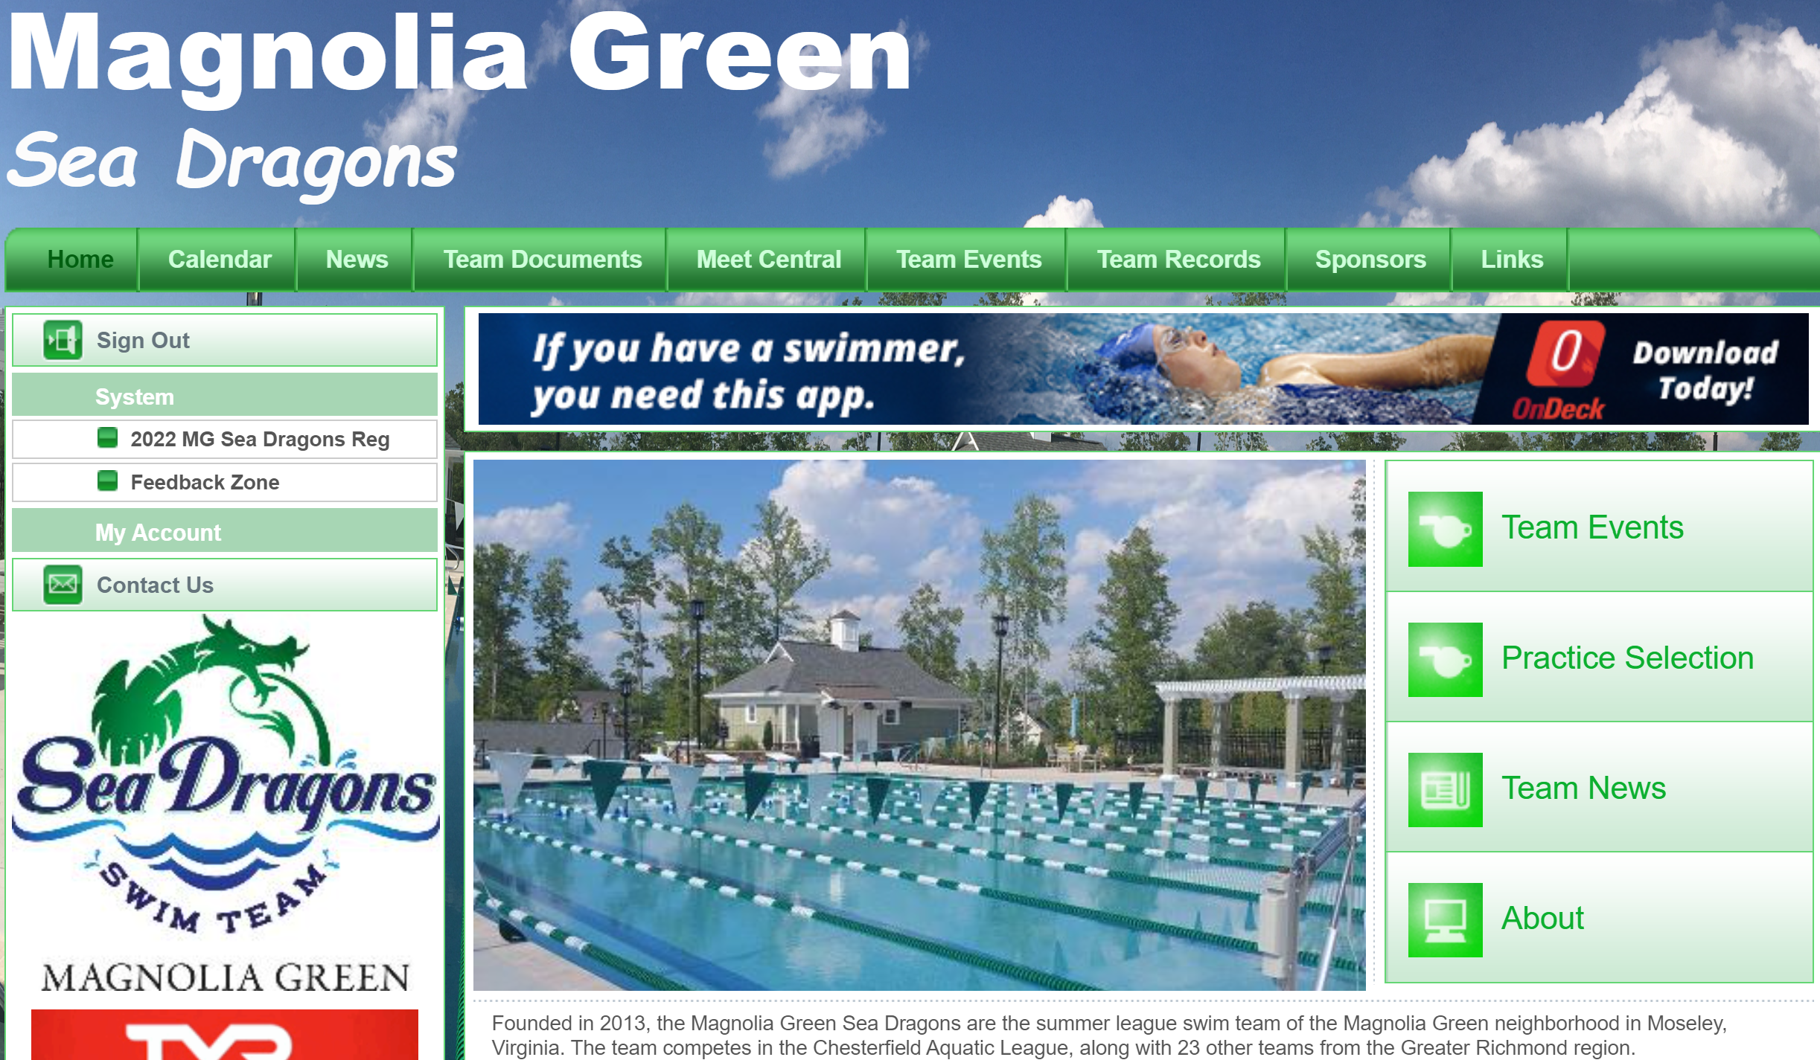

- Click the Team Events tab at the top of the screen. You will see the Upcoming Meets listed. Under each meet, you will see a button for Attend/Decline (my screen shows Edit Commitment because my swimmer is already declared) and a button for Job Signup.
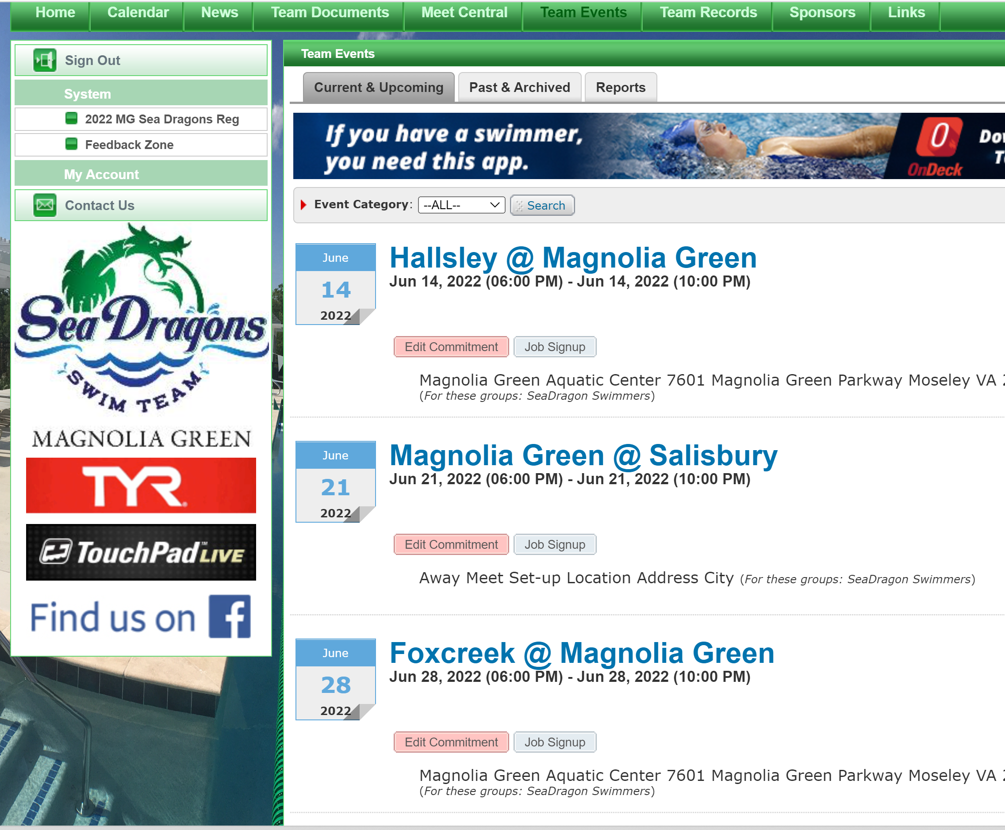
- Click Job Signup
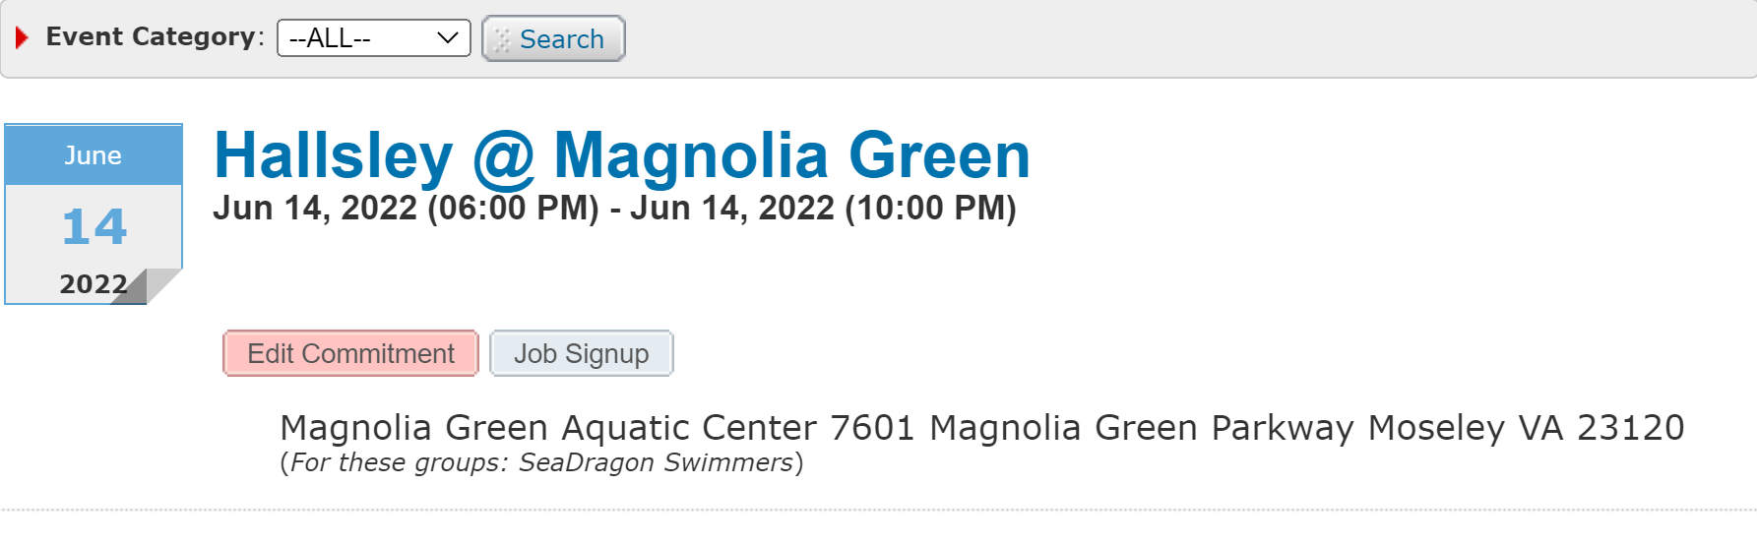
- Select the checkbox of the job you would like to commit to and click +Signup at the top of the screen.
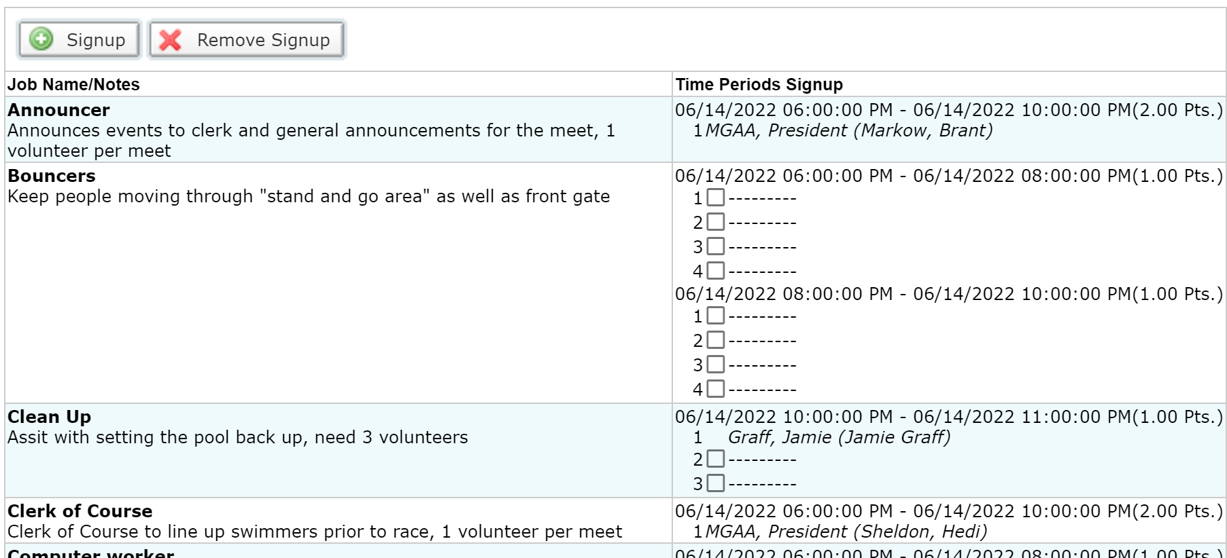

- Enter the name of the person volunteering and click Signup. NOTE: You MUST sign up for volunteer positions from your Team Unify account to receive credit for volunteering at a meet. All families of registered swimmers are required to volunteer for 3 meet halves throughout the season. Families who do not meet their volunteer commitment are subject to a $50 fee per meet half missed according to the Volunteer Contract signed during registration.
